# **Hospital DB Output**

# This is the Home page of our Hospital where both patient and admin/DOCTOR can interact with the DB

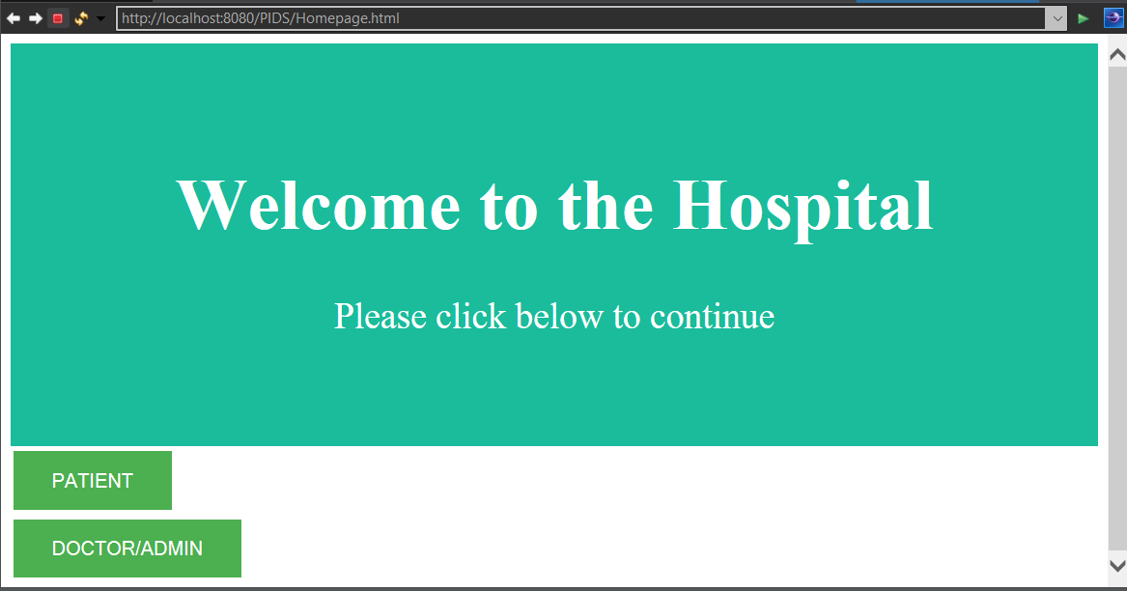

# Once clicked on Patient Button the page will be redirect to the patient login page where patient can book an appointment for a patient for that we have to provide their respective name, dob, contact, gender, email.

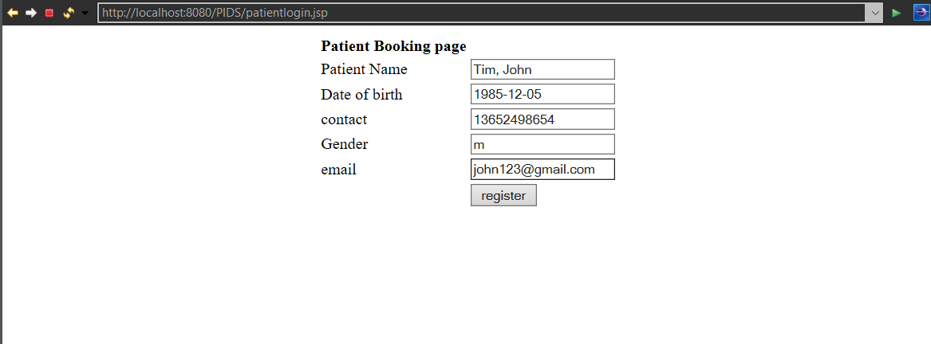

# Once data is given by the patient, patient must click the register button where they get a pop up that the registration is confirmed, and the data is successfully stored and forwarded to admin panel

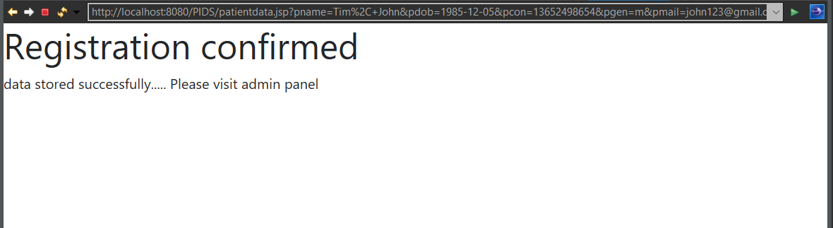

# As we can see in our database Below is the newly registered Patient to the hospital which got updated in the database

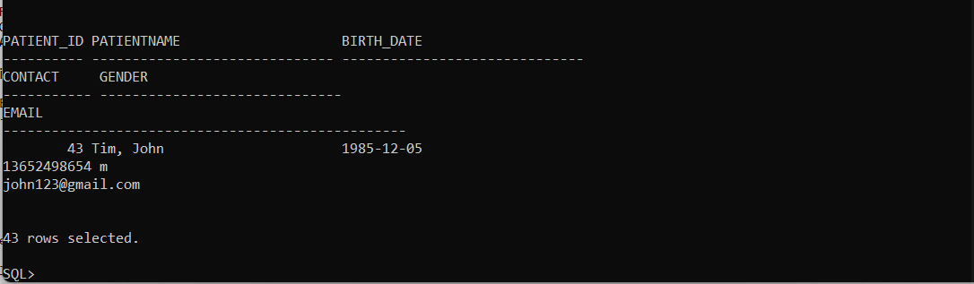

# Now If the DOCTOR or Admin wants to interact with the DB then they can click on doctor/admin button.



# Once click the page will be redirected which will show another button as below.

# I

# In this we can access the new patient’s information who has registered earlier and doesn’t have appointment and now admin assigns the patients to the respective doctors based on their symptoms.

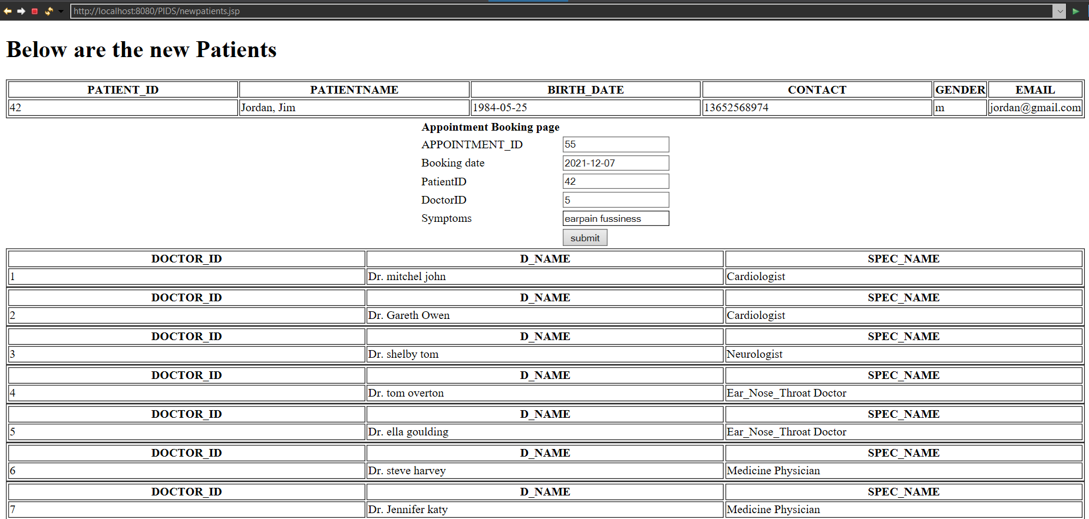

# After entering the data for appointment booking it will be stored successfully and it assigns the respective doctor to the patients based on their symptoms. And sent to be Treated.



# Here we can get the data of new appointments of the patients along with their symptoms who aren’t yet been treated and the doctors that are assigned to them and also the doctor treats and gives medicine to the patients based on their symptoms and updates the information in the fields given below

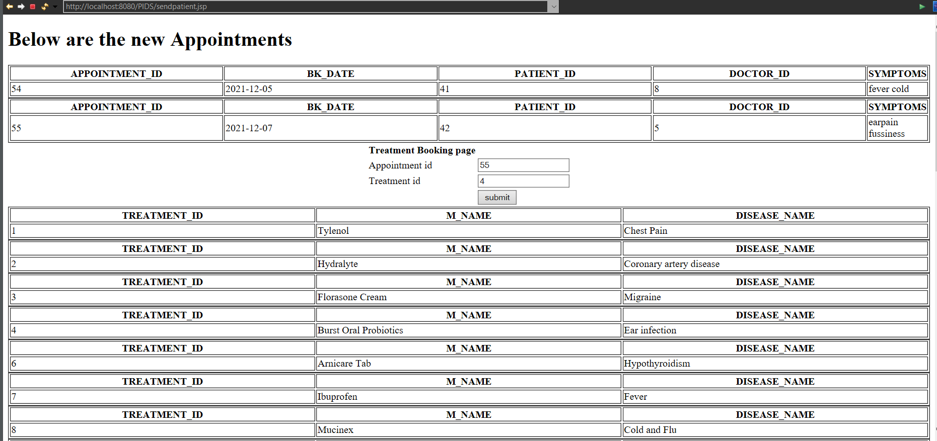

# 

# Patient is treated successfully.



# Now if we check in the DB the Presccription table is updated as we have Created a trigger to update treatment data automatically once the patient is treated

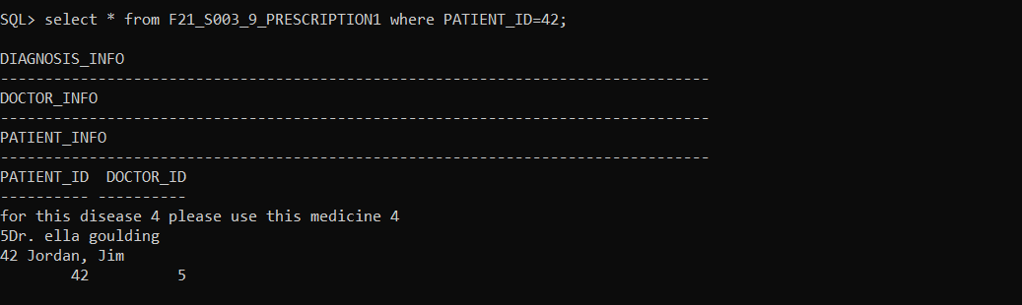

# Now once the prescription is updated a EMR record of the patient treated is updated in EMR table with the help of triggers and this record will be useful in the future as a business goal

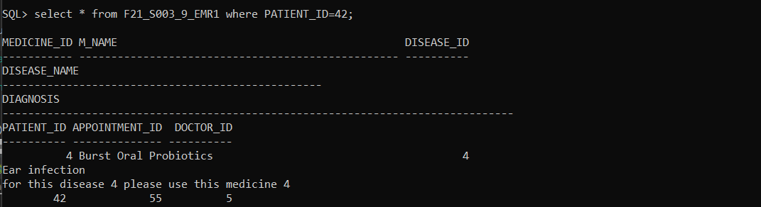

# Here where we updated the patient registration form where the patients have an access and can check their existing prescription and medical records.

# This is the required medical record data of the patients which is retrieved from the hospital database and give them an overview of the treatment.

